# Source Control Snapshot

## Version Control

We have created a Master Branch then for each Sprint we will be creating a new Branch.

### Branches

**Master (default)** represents the currently working code.

**Blkdevelopment-ver-1** represents the files, documentation and code created and produced during Sprint 1.

**Blkdevelopment-ver-2** represents the files, documentation and code created and produced during Sprint 2.

**Blkdevelopment-ver-3** represents the files, documentation and code created and produced during Sprint 3

**Blkdevelopment-ver-4** represents the files, documentation and code created and produced for the handover.

## Top Level Repository

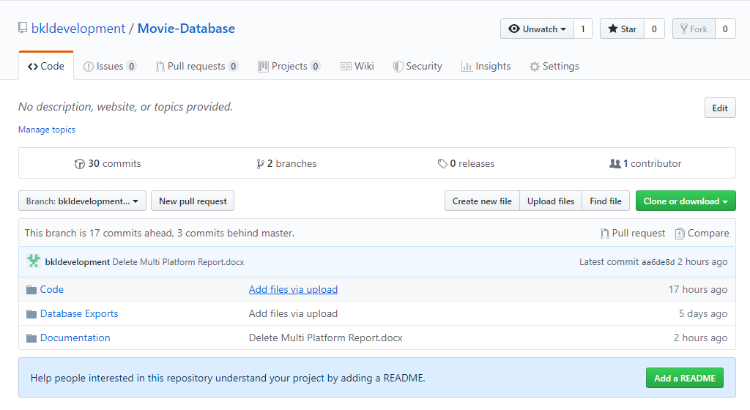

## Code Level Repository

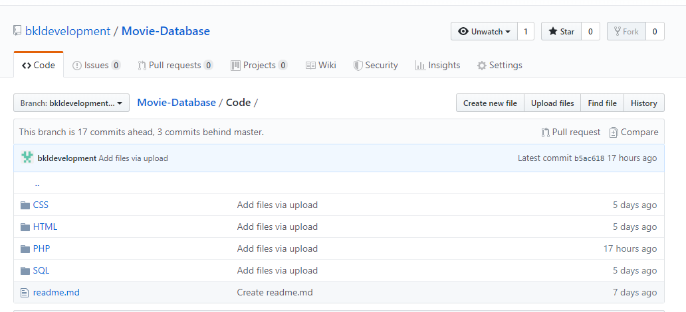

## Database Exports Level

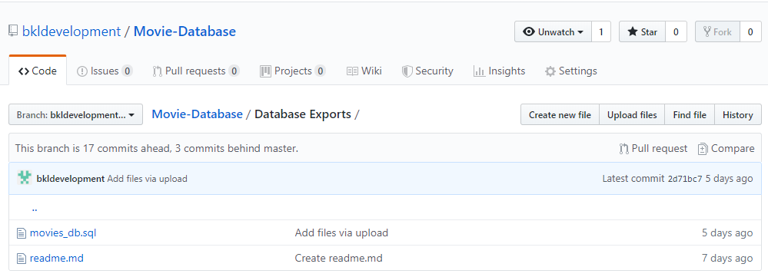

## Documentation Level

